**Assignment 9**

**WRC078BEI048**

1. **Capture the packet while sending an http request also capture the response. Dissect the request and the response.**

**Ans:**

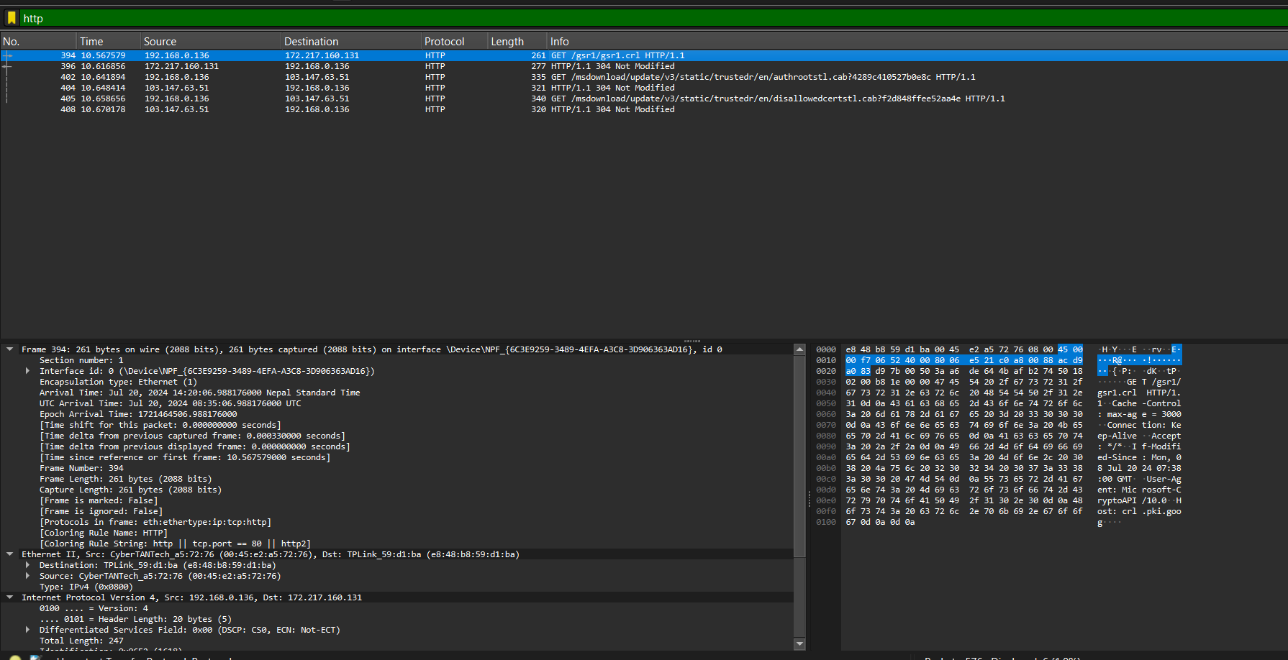

**1. HTTP Request Dissection**

An HTTP request consists of several components: the request line, headers, and optionally a body. Here’s how to dissect it:

**Request Line**

* **Method**: Indicates the HTTP method used (e.g., GET, POST, PUT, DELETE).
* **URL**: The path of the resource being requested.
* **Version**: The HTTP version being used (e.g., HTTP/1.1).

**Example:** GET /index.html HTTP/1.1

* **Method**: GET
* **URL**: /index.html
* **Version**: HTTP/1.1

**2. HTTP Response Dissection**

An HTTP response consists of a status line, headers, and optionally a body. Here’s how to dissect it:

**Status Line**

* **Version**: The HTTP version used (e.g., HTTP/1.1).
* **Status Code**: A three-digit code indicating the result of the request (e.g., 200, 404, 500).
* **Reason Phrase**: A brief description of the status code (e.g., OK, Not Found, Internal Server Error).

**Example:** HTTP/1.1 200 OK

* **Version**: HTTP/1.1
* **Status Code**: 200
* **Reason Phrase**: OK

**C. Capture the packet while sending an email.**

**Ans:**